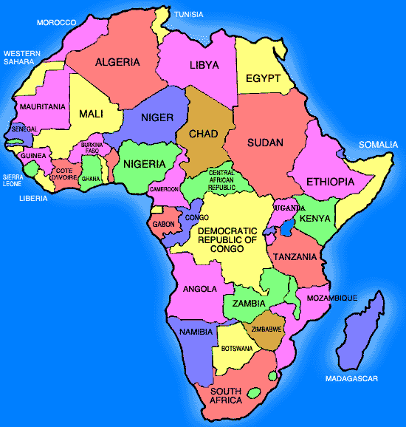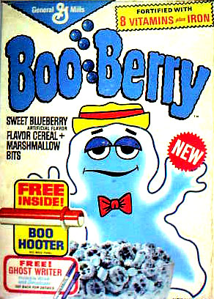Africa in a Box!

***Your objective:*** *Create a cereal box showing different aspects of your assigned country.*

Bring in an empty cereal box **(extra credit it you bring in more than 1)**

* Use drawings, photos from magazines, the computer and other visual aids to help design your box.
* Front panel:
  + **Map** of the country, **flag** and **visuals** of the land.
  + Written description of the landforms that exist within your country
* Back panel:
  + **Photos** of the people
  + Written description of the people, their cultures, traditions, religions
* 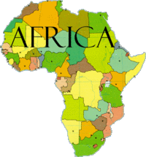Side Panel - Economy:
  + What resources do they have?
  + What occupations are common
  + What is the GDP – know what that means
  + Any other pertinent details
* Side Panel – Statistics:
  + Population
  + Life expectancy
  + Religions
  + Other interesting Facts
* The name of the cereal should reflect the country’s name or a part of its culture
* Inside Box:
  + **Three** items representing the country (ie: a wool scarf to represent sheep raising)
* Create a commercial promoting your “cereal”.
  + This will be your presentation to the class.
  + [](http://www.clipartguide.com/_pages/0511-0904-0419-5924.html)You can receive ***extra credit*** for videotaping your commercial and showing it to class.



|  |  |
| --- | --- |
| Front Panel | 20 |
| Back Panel | 20 |
| Side Panel - Economy | 10 |
| Side Panel – Statistics | 10 |
| Name of Cereal | 5 |
| 3 Items | 15 |
| Commercial | 20 |
| EC – video | 0-15 |
| **Total** | **100** |

**Assessment Grade!**

You will be given class time on Laptops for research and class time to assemble your project! Start eating that cereal and bring in a box by Monday 5/8/17.

Project Due date: Friday, May 12

