Chapter 5 Section 1

English Laws and the Enlightenment

One source of inspiration was the _________________________. This makes even government officials subject to law. England had limited the power of its Kings and queens in two documents. These were the ________________________________ and the ______________________________________. The ___________________________________ was a document signed by King John in 1215 and made the king subject to law. The ________________________________________, passed in 1689, declared the supremacy of Parliament. It kept the king or queen from changing laws without Parliament’s consent. As a result, the people’s representatives had a strong voice in England’s government.
Many Americans were also influenced by the Enlightenment, a _____________________________ movement that emphasized the use of ___________________ to examine old ideas and traditions. Philosopher, _____________________________ believed that a social contract existed between political rulers and the people they ruled. Baron de Montesquieu argued that the only way to achieve liberty was through the ____________________________ of governmental powers.

American Models of Government
Americans had their own models of self=government to follow, like __________________________, The Virginia House of Burgesses, and the ________________________________________. In 1639 the people of Connecticut drew up the English colonies first written ______________________________________. A constitution is ________________________________________________________________________________________________ ________________________________________________________________________________________________________________. In addition, the Declaration of ____________________________ clearly set forth the beliefs on which Americans thought government should be based.
To keep individual __________________________ from gaining too much power, the new state constitutions created _______________________ governments, or governments in which all __________________________ have to obey the laws. Most state constitutions had ruleds to protect the rights of citizens or those accused of crimes.
Thomas _________________________ ideas about _____________________________ freedom were included in the __________________________ Statute for Religious Freedom. This document declared that no person could be forced to attend a particular church or be required to pay for a church with ________ money.

Right to Vote
Under British rule, only ___________, _______________ men that owned land could vote. Many state’s constitutions expanded ____________________________, or the right to vote, by allowing any white man who paid taxes to vote. In every state, only landowners could hold _____________________________. Some states originally allowed women and free African Americans to vote, but theses rights were soon taken away.

Articles of Confederation
The Second Continental Congress was organized to create a national ________________________. The Continental Congress appointed a Committee of Thirteen, with one member from each colony. This group was assigned to discuss and draft the ________________________________________________________, the new national constitution.
Under the Articles of Confederation, Congress would become the single branch of the national government, but it would have limited powers in order to protect the ___________________ of the people. Each _________________ had one vote in the Congress. __________________ could settle conflicts among the states, ______________________, borrow money, and make treaties with other countries. Congress could also ask the states for money and soldiers. However, states had the power to ________________ these requests. The government did not have a _____________________ or a national court system.
The Second Continental Congress passed the __________________________________________________ on November 15, 1777. Then it went the Articles to each state legislature for ______________________ or official approval before the new national government could take effect.
Conflicts over claims to western lands slowed the process, but by _________________ every state except __________________________ had ratified the Articles. Maryland’s leaders refused to ratify until other states gave up their western land claims. Thomas Jefferson assured Maryland the western lands would be made into new ______________ , rather than increasing territory for existing states. In March 1781 Maryland ratified the Articles. This put the first national government of the United States into effect.
Northwest Territory
Land Ordinance of 1785 set up a system for surveying and _____________________ western lands. The land was split into townships, which were ___________ square miles divided into 36 lots of 640 acres each. One lot was reserved for a ____________________________________ and four lots were given to veterans. The remaining lots were sold to the public.
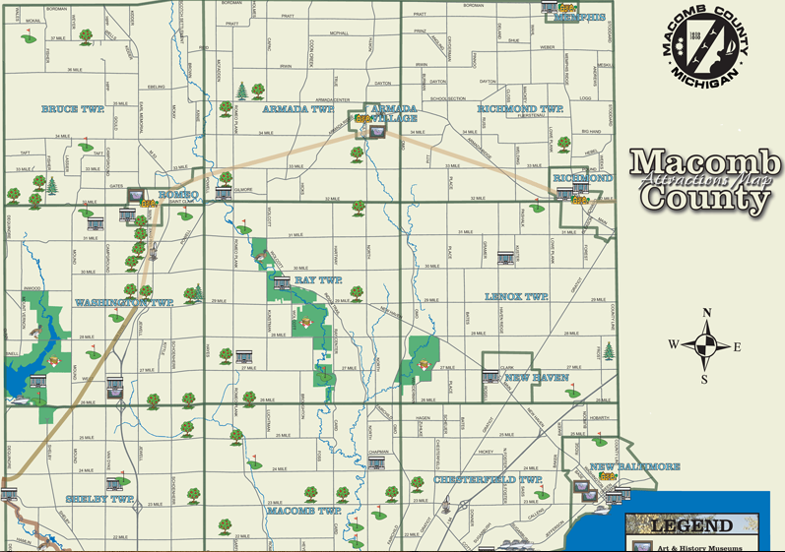
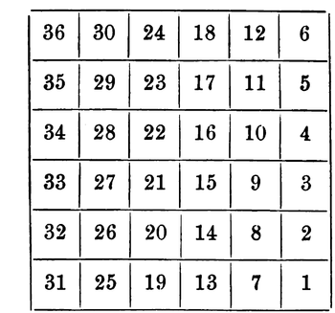

The Northwest Ordinance of 1787 established the ______________________________________________. This included areas that are now in Illinois, Indiana, Michigan, Ohio, Minnesota, and Wisconsin. The Northwest Ordinance created a system for bringing new states into the Union. Congress agreed that the Northwest Territory would be divided into several smaller territories with a __________________________ appointed by Congress. When the population of a territory reached _________________________, its settlers could draft their own constitution and ask to join the union.
In addition the law protected civil liberties and required that _________________________________ be provided. Finally, the ordinance stated that there shall be neither slavery nor involuntary servitude in the territory. This last condition ____________________ slavery in the Territory and set the standard for future territories.

