Inventions: Where Would We Be Without Them???

Task:
- Choose an invention from 1750-1850
- Create an advertisement for your invention
- Try to entice people to either buy your product or use your invention
- Be creative, but realistic. Your advertisement should reflect the era in which the invention occurred.
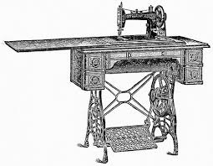
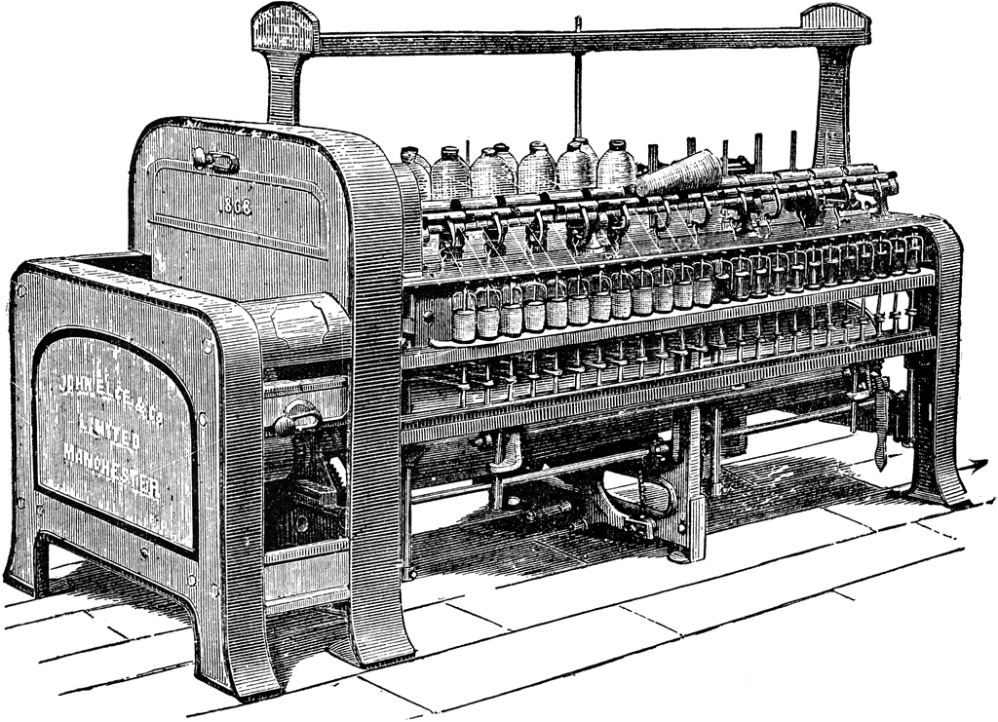
Rubric:
Task | Points Possible
Valid Invention from 1750-1850 | 10
Creativity | 5
Description | 10
Illustration or Picture | 5
Entice to purchase or use | 5
Name the Inventor | 5
Date of invention | 5
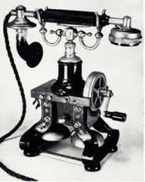
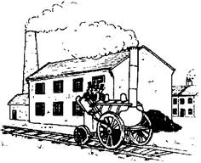
Your advertisement is Due Friday, April 21
You are able to work with one other person from the same class.
If you have any questions please don’t hesitate to message me via remind or email me at cwest@wcskids.net
I can’t wait to see what you will share!

