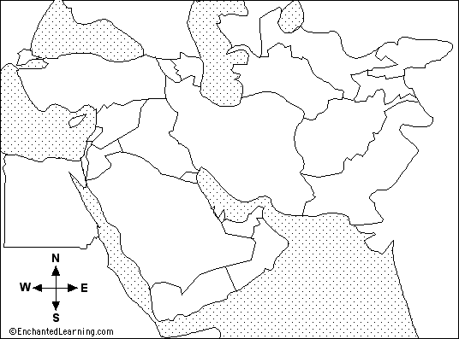

Label the following for review:
- Mediterranean Sea
- Black Sea
- Constantinople
- Red Sea
- Egypt
Use BLUE for any water
Use Brown for any land
Label the following new items:
- Mecca
- Medina
- Persian Gulf
- Baghdad
- Caspian Sea
- Indian Ocean

List 5 events from Mohammad’s life
- _______________________________________________________________
- _______________________________________________________________
- _______________________________________________________________
- _______________________________________________________________
- _______________________________________________________________
Create a timeline of Mohammad’s life:

