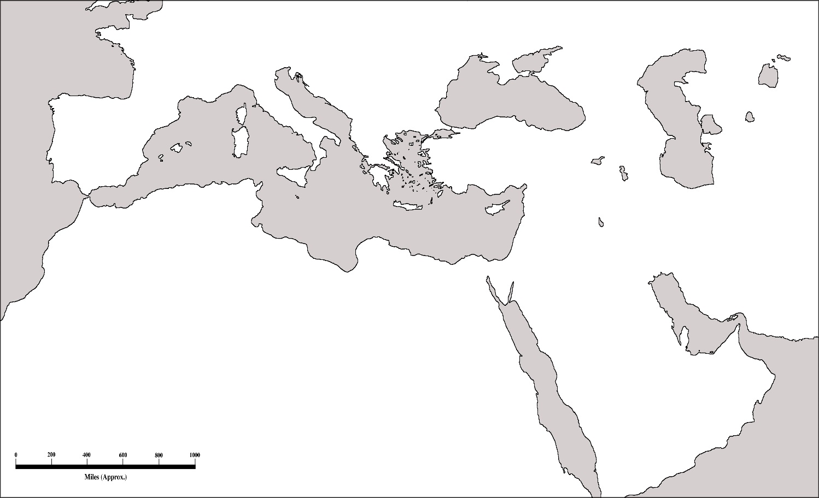

Carefully color all the parts of the Byzantine Empire
Identify the following:
ο Italy o Greece o Mediterranean Sea o Black Sea
O Aegean Sea o Adriatic Sea o Constantinople o Athens
O Rome o Danube River o Euphrates River o Tigris River
O Crete o Cyprus

Why was the location of Constantinople a good one? (Answer in a complete sentence)
______________________________________________________________________________________________________________________________________________________________________________________________________________________________________________________________________________________________________
List important dates about the Byzantine Empire – at least 5 events (more if using internet)

Create a timeline showing these events in order! (should be from 476-1453)

Provide details explaining the differences between the Western and Eastern forms of Government:
Eastern Government | Western Government

After viewing several examples of Mosaic Art… Create your own Mosaic Art. Sketch your picture here and check with Mrs. West first before you proceed with art paper.

