Discovering the Underground Railroad
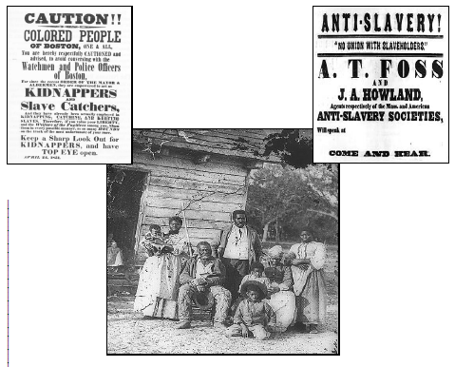

Name ___________________________ Score ______
To Be Free
Write about what “Freedom” means to you:

Day-to-Day Life

Enslaved people endured many hardships as the “property” of another person:

Many slaves worked from sunrise till sunset, resting only during meal times.
Slaves received no pay.
Slaves could not go anywhere without permission from the “master”.
Slave children began working usually by six years old.
Slaves were punished often for even the simplest of reasons.
Slaves often had little to eat and few clothes to wear.
Slaves were not allowed to choose their own job.

Though restricted and degraded in every way, the undying hope for freedom and the spirit and involvement of the extended family became the survival tool for many enslaved persons. It was also this very family which made the decision to run away a difficult one. Escaping did not guarantee freedom, but it often did mean leaving behind family and friends.

Draw or Write:
Two ways that your life is different from that of an enslaved person.

Escape routes over land spread out like a tangled web throughout the United States, into Cana-da, and Mexico. Other routes were traveled by water to northern coastal cities, south towards the Caribbean, or west towards the coast of California, Alaska or Hawaii.

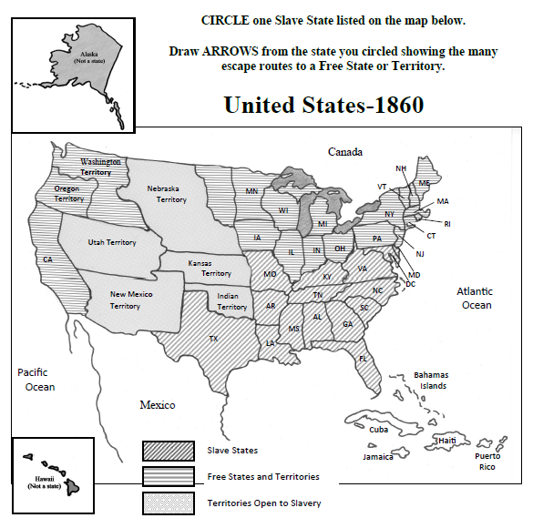

Although many states and territories had banned slavery by 1860, freedom seekers who had escaped to free states and territories could be captured by slave catchers and returned to slavery because of the Fugitive Slave Act of 1850. After the 1850 Act, many freedom seekers in free states were forced to continue their escape to countries outside the United States.
Put a STAR in the state where you live.
Draw an ARROW of the route you would use to escape slavery after 1850.
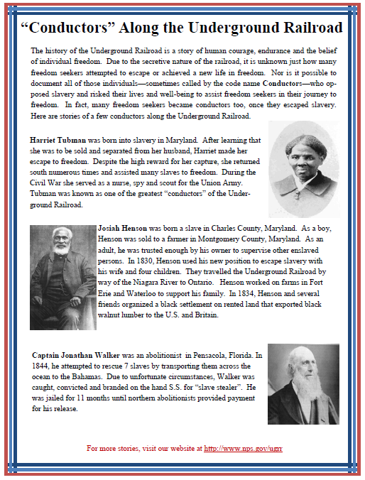

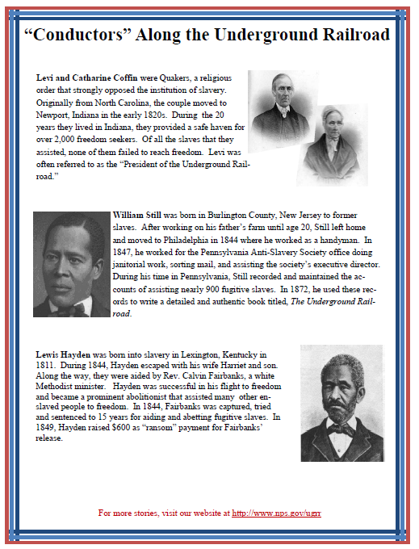
Draw a route that our Freedom Seeker Eli can take to safely reach Freedom.
Remember, this is a secret journey and there are many dangers along the way. Read the stories of successful Freedom Seekers and Conductors on pages 5, 6, 8, and 9 to help you find your way.
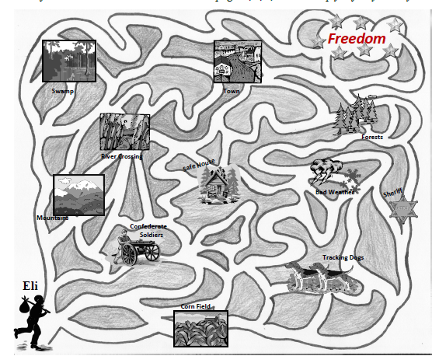

Name 2 dangers that might stop Eli from reaching Freedom. Why? __________________________________________________________________________________________________________________________________________________________
_____________________________________________________________________________
Name 2 safe places for Eli to hide. Why?_________________________________________
__________________________________________________________________________________________________________________________________________________________
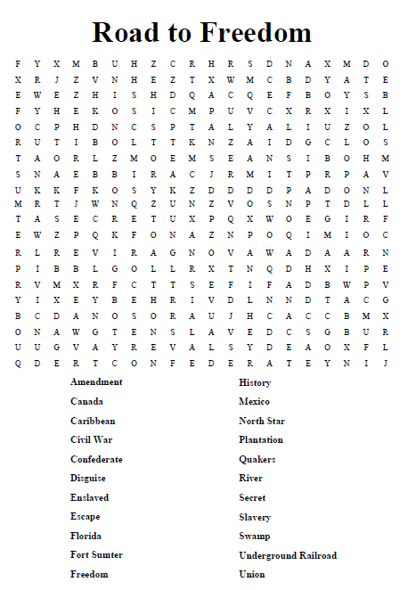
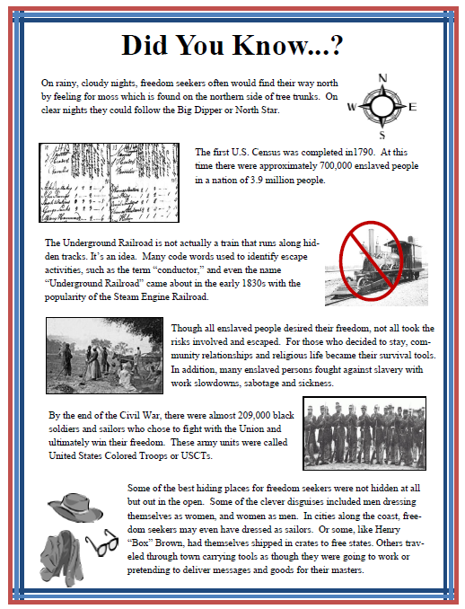
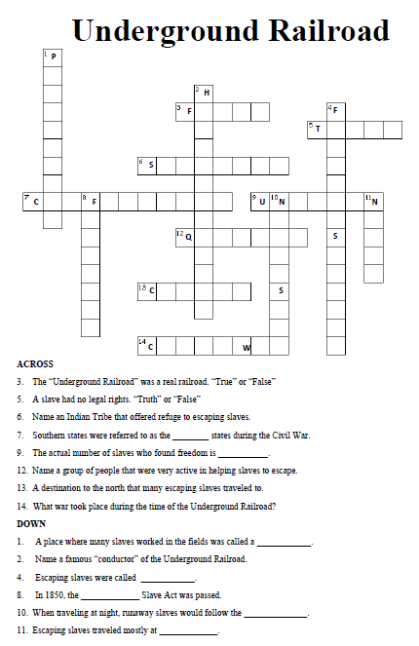

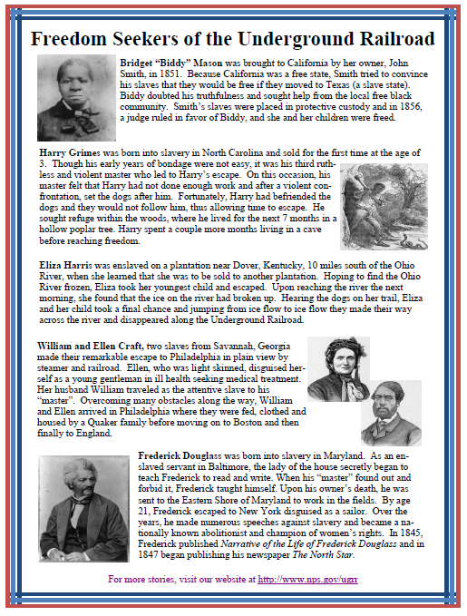
Imagine that you and your family are escaping to freedom along the Underground Railroad. Write a short entry about your journey.
How did you travel, where did you go, and did anybody help you along the way? What type of difficulties did you have? Remember, your travels are a secret and you need to be clever so you don’t get caught!

Read the stories of successful Freedom Seekers and Conductors on pages 5, 6, 8, and 9 to help you get ideas.

