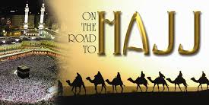
The Hajj
Your task:
- What is Hajj
- Create a map explaining the 5-day process
- Investigate your chosen day, explain what happens on that day and illustrate it.

Use this to help guide you
- Define Hajja:

- List the 5 stops/tasks
- _______________________
- _______________________
- _______________________
- _______________________
- _______________________
- Your assigned day is ________________
What is it? __________________________________________________
__________________________________________________
How will you illustrate it? (might want to sketch out on the back first)

