Why does Washington say Americans should protect their Union from attack?
Page 248 in your book
- __________________________________________________________________________________________________________________________________________________________________________________________________________________

Why does the name American create a feeling of shared pride?
- __________________________________________________________________________________________________________________________________________________________________________________________________________________
- Why does Washington think the national government will be a success?
- __________________________________________________________________________________________________________________________________________________________________________________________________________________
- What events happened before Washington left office that might have led to his warning against political parties?
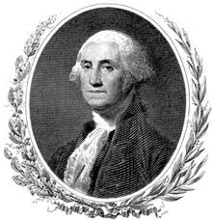
- __________________________________________________________________________________________________________________________________________________________________________________________________________________
- Why did Washington suggest neutrality as a foreign policy?
- __________________________________________________________________________________________________________________________________________________________________________________________________________________
- What warnings did Washington give the nation in his Farewell Address?
- __________________________________________________________________________________________________________________________________________________________________________________________________________________

